Data Methodology

# **Step 1: Storyboarding**

# Reviewed the dataset thoroughly to understand its structure and key variables.

# Identified significant fields that would be essential for analysis.

# Created a visual representation to present Insights and Recommendations.

# Developed a basic outline for the slides.

# **Step 2: Data Wrangling**

## **Univariate Data Analysis:**

* Used Tableau to analyse individual variables.
* Examined distributions, unique values, missing data, and potential outliers.

## **Data Quality Assessment:**

* Identified a small percentage of missing values that would not significantly impact the analysis.
* Observed a right-skewed distribution for the price variable.
* 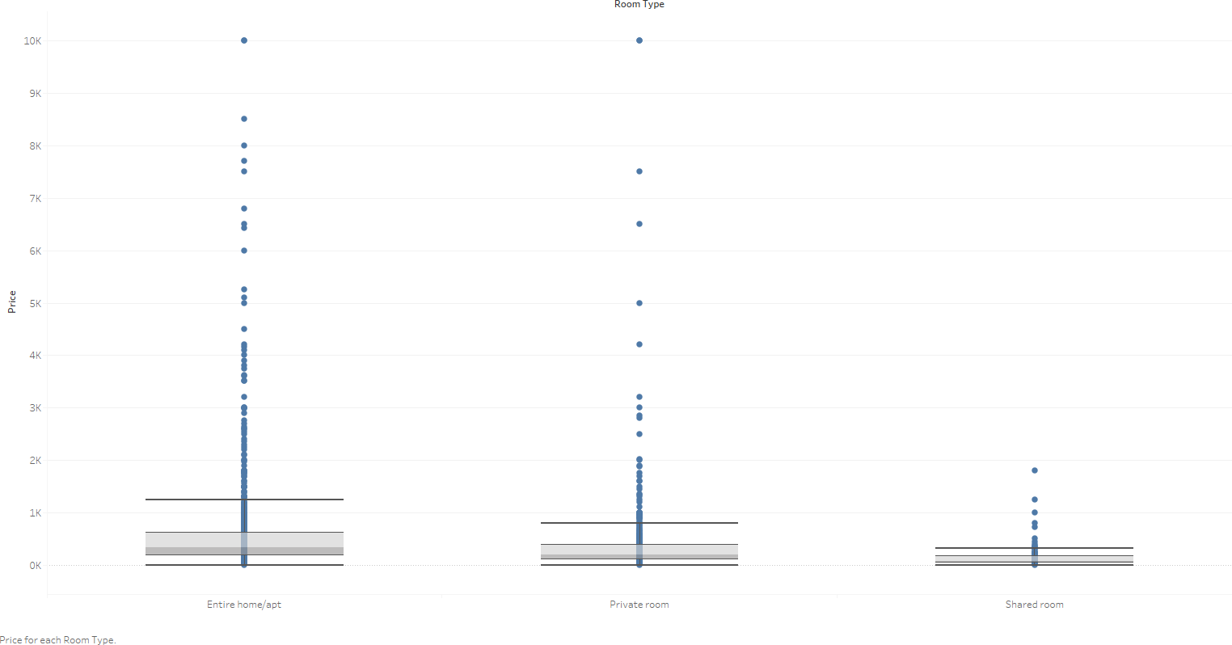Noted the presence of outliers in the price data, as indicated by the boxplot.
* Created a calculated field for grouping the no of nights the customer has booked to understand the distribution

* Created a calculated field of for reviews per host listing using the below formula to understand the spread of reviews

**Step 3: Data Analysis**

* Create a Bar chart to understand the Top 10 hosts by Sum of Price to understand the impact of the customers and how they are faring against the number of bookings
  + **Sonder (NYC)**, despite being the most expensive option, has the highest number of bookings (327). This suggests that customers are willing to pay a premium for Sonder's offerings, possibly due to its location, amenities, or reputation.
  + **Michael** and **David**, on the other hand, have a relatively high number of bookings compared to their pricing, indicating they may offer good value for money.
  + While **Sonder (NYC)** commands the highest price, it's worth noting that other hosts with fewer bookings are charging similar rates. This suggests that pricing may not be the sole determinant of popularity.
  + However, there are exceptions, such as **Sally** and **Kara**, who have a relatively low number of bookings despite having a decent number of reviews. This could indicate that these hosts may have recently joined the platform or have a niche market that limits their booking potential.

* Distribution of price and room type by Neighbourhood group

* Created a chart to understand the pricing of each room category against different neighbourhood group
  + Average price of entire Home/Apt is the highest and approx. 100% more than private rooms. For Brooklyn and Staten Island, the average price varies by 150%
  + Private room’s price is approx. 10% more than shared rooms except Brooklyn and Manhattan approx. 40%
  + Manhattan is costliest overall and the cheapest are:
    - Entire apt: Bronx
    - Private room: Staten Islands
    - Shared room: Brooklyn

* Insights from above graph:
  + Entire apartments are popular and so are private rooms
  + Except in Manhattan, shared rooms are very unpopular
  + Entire room’s reviews per listing for Manhattan is 35% lower than the overall average and number of listings is the highest

# **Step 4: Presentation**

* Made the presentation adhering to best practices and pyramid principle
* Added recommendations for the respective departments